HOK BCF Reader 

*(Updated 2013-06-21 by Jinsol Kim)*

## Overview

BCF Reader was developed to improve the interoperability between Solibri Model Checker and Revit for commenting on issues generated from Soibri. By allowing Revit to take control of the Solibri comment data, users can directly modify Revit model elements related to Solibri issues.

Contents

Overview 1

***1.*** ***About BCF*** 2

***2.*** ***User Interface*** 2

***3.*** ***Walkthrough: BCF Reader*** 3

3.1 Opening BCF 3

3.2 Writing to BCF 5

3.2.1 Renaming Issues 5

3.2.2 Modifying Comments 5

3.2.3 Enlarging Images 7

3.2.4 Saving Changes to BCF 8

3.3 Creating 3D View with Related Components 8

3.4 Writing Shared Parameters 10

# ***About BCF***

BIM Collaboration Format (BCF) is an open standard to enable workflow communication between different BIM software like Tekla and Solibri. The BCF is built on XML schema that will contain entries of the information of issues and comments found in the BIM model. Sharing data with BCF file will give BIM coordinators benefits of a reduction in the data transfer with much lighter file size implementing improved workflow.

*See details in buildingSMART-tech*

<http://www.buildingsmart-tech.org/specifications/bcf-releases/bcf-intro>

# ***User Interface***

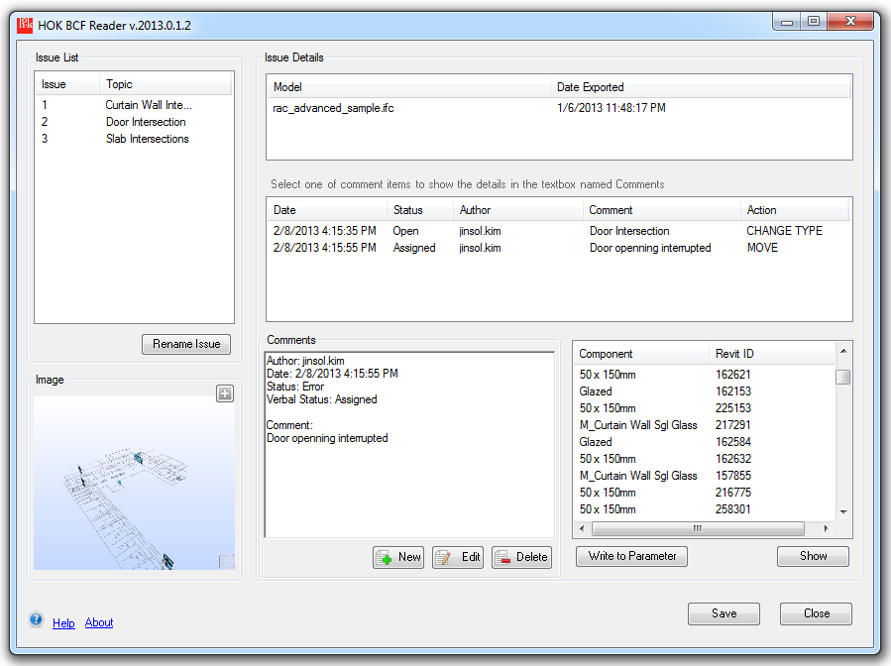

9

8

7

6

5

4

3

2

1

1. Issue List: Tracking ID and Topics of Issues comes from Solibri. Users can rename the Issue ID. When selecting on a row of each issue, corresponding issue details, an image and components included the issue will be updated.
2. Issue Detail: Model refers to the IFC model to which the principal objects reside, and Date Exported refers to the date exported to IFC.
3. Comment List: Date stamp refers to when the comment was created in this or other applications. Author is derived from the app in which the comment was made. Users can specify an action type to define the solution for the comment. When selecting on a row of comments, detailed comment area will be updated.
4. Image: This shown image comes from Solibri. The image will vary depending on a selected issue on the issue list. Hitting the plus sign opens the full size image.
5. Comment Detail area: This will provide an extended area for the selected comment.
6. Comment Modification: This will allow users to add a new comment, or edit/ delete an existing comment.
7. Related Components: This will lists the component name from Solibri. If the component can be found in the Revit model, it will display with the Revit ID, and the show button takes you to the element.
8. Write to Parameter: parameters values with the information of a selected comment will be written in the selected components.
9. Help and About: The Help label will give access to the instruction documentation and the About label will display the general information of this application.

# ***Walkthrough: BCF Reader***

## Opening BCF

Find BCF Reader command button in the HOK Tools tab, and click the button to open a BCF file. The open file dialog will filter a file extension, *.bcfzip.

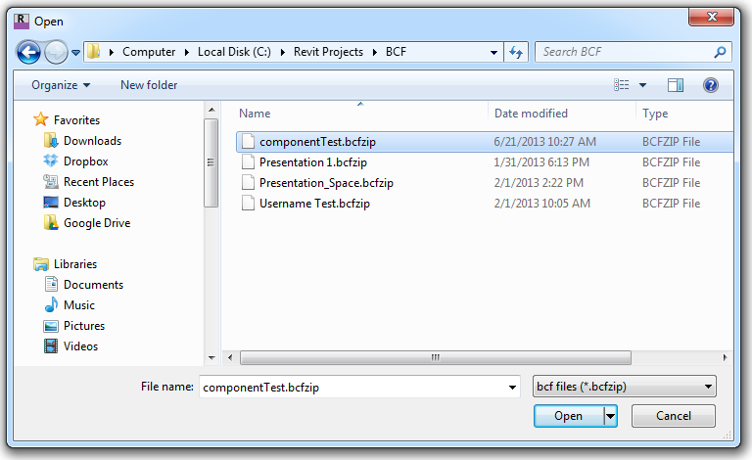

If you’ve ever opened bcf files, you will see a task dialog to choose options below.

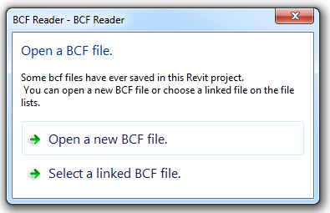

If the first option is chosen, it will show you the open file dialog like above. Otherwise, if you select the second option, it will display the lists of BCF worked on the current Revit project file.

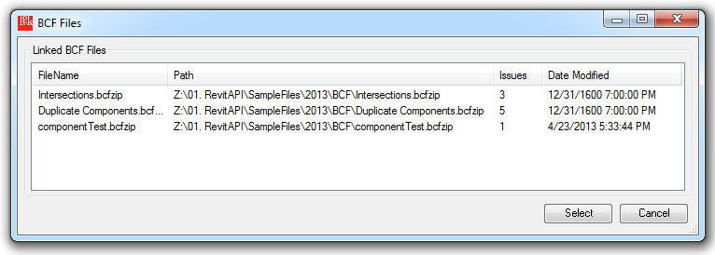

You can select one of items in the file lists and click the Select button to open the file, or double-click the item in the list.

## Writing to BCF

### 3.2.1 Renaming Issues

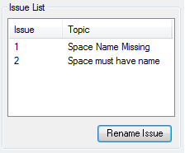 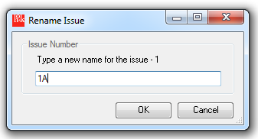

Click the Rename Issue button on the bottom of the Issue List, so that you can type a preferred text for the Issue Id. These Ids will not be readable in Solibri.

### 3.2.2 Modifying Comments

When you select a comment among items in the comment list, you will see the details in the extended comments area.

Click the New button to start creating a new comment on the selected issue. 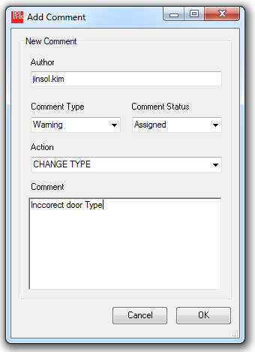

Author, Comment Type, Comment Status, Action*, and Comment can be defined for the new comment. (Action is HOK specific standard. Only readable through HOK BCF Reader)

Click the Edit button to modify a comment. 

You will see the same windows like adding a new comment but filled with the information of the selected comment.

To delete a comment associated an issue, select a comment item in the list box, and click the Delete button.  It will ask you to confirm the deletion.

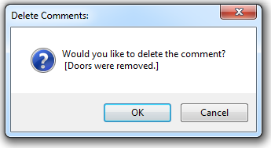

### 3.2.3 Enlarging Images

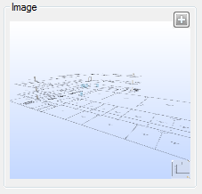 Click the + button located on the top right corner.

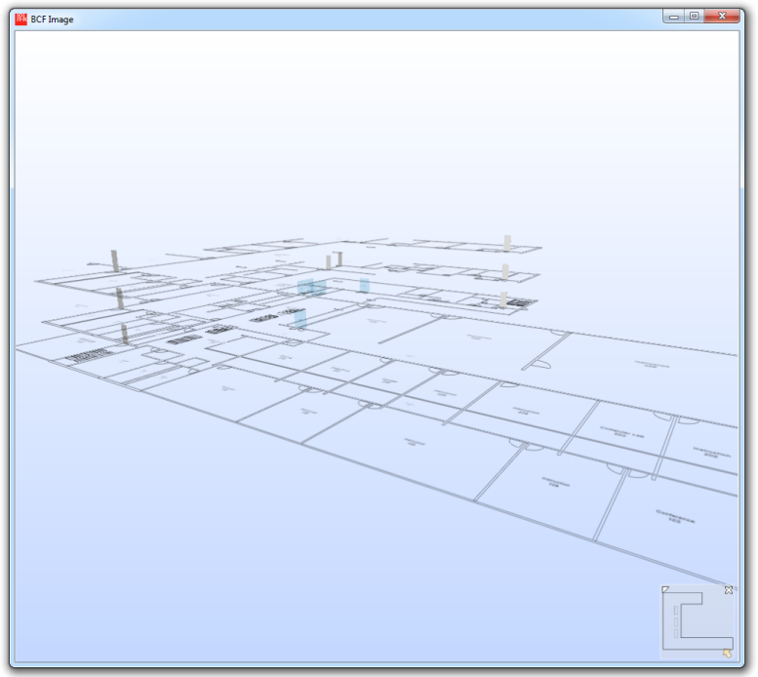

A new window will be popped up with the enlarged image comes from Solibri.

### 3.2.4 Saving Changes to BCF

Don’t forget to click the Save button in the right bottom corner, in order to apply all those changes into the opened BCF file.

## 3.3 Creating 3D View with Related Components

If you want to find components in the opened Revit project, select one or multiple items in the component list, and click the Show button to make selection of those Revit elements in the background.

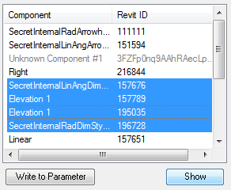

**If a component doesn’t provide an id information of BIM authoring tool, it will be marked as “*Unknown Component*” with a unique Id derived from the IFC file. If a component cannot be found in the current Revit project, it will be marked as “Missing Component” with Revit Element Id.

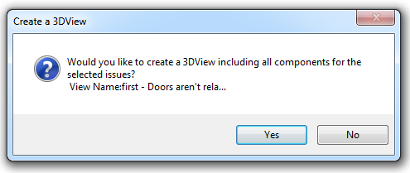

When you click the Show button, it will ask you whether you want to create a 3D view with the related components or not. If yes, it will create a 3D view of which name includes the id and topic of the selected issue.

After the completion of creating view, you will see the notification message.

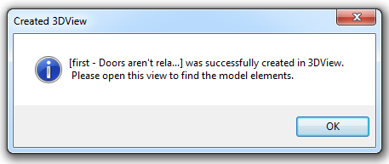

Find the created 3D view in the project browser. You will see the related components are still selected and highlighted.

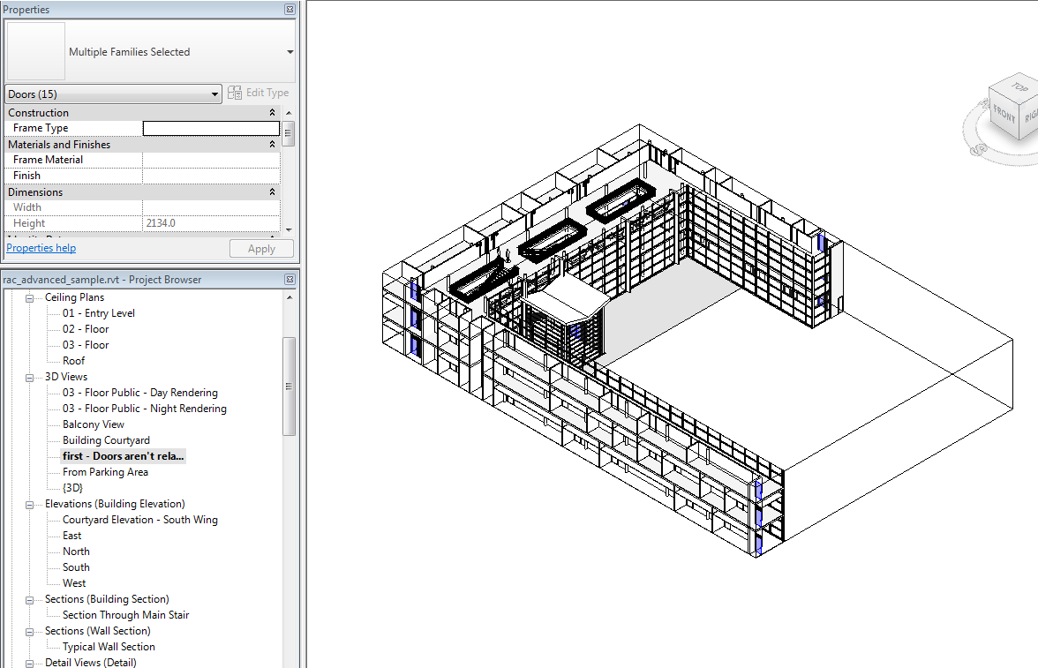

## 3.4 Writing Shared Parameters

Before writing shared parameters into selected component, make sure BCF specific parameters existed in the category of elements.

*Required Parameters*:

“BCF_Action”, “BCF_Comment”, “ BCF_Date”, “ BCF_IssueNumber”, “ BCF_Name, BCF_Topic”

Type of Parameter: Text

To start writing shared parameters, select a comment and component items in each list box, and click the “Write to Parameter” button.

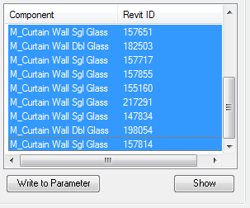

You can confirm the information of BCF parameters and their values from the dialog box.

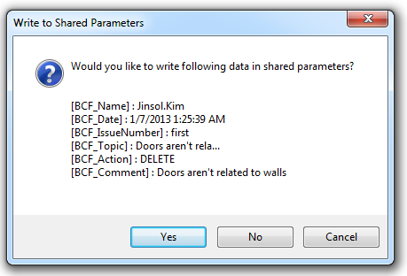

A notification message will inform you the completion of the task.

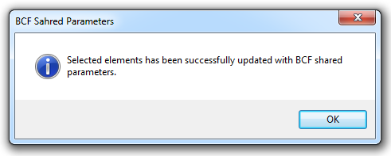

Once you select the component, you will be able to find all those parameter values in the instance properties and they were successfully written.

